Apply filters to SQL queries

Project description
In this project scenario, I work as a security specialist for a sizable company. Investigating security issues to help keep the system secure is a part of my job. Recently, I came across some conceivable security flaws involving employee computers and login attempts. My responsibility is to review the data in the organization's employees and log_in_attempts tables. To retrieve records from various datasets and look into potential security issues, I will need to use SQL filters.

Retrieve after hours failed login attempts
Since I recently discovered a potential security incident that happened after hours at the company, I will need to query the log_in_attempts table using a command and review the activity. The building closes at 18:00 military time which is 6pm. I will also be using success = ‘0’ meaning a failed login attempt.
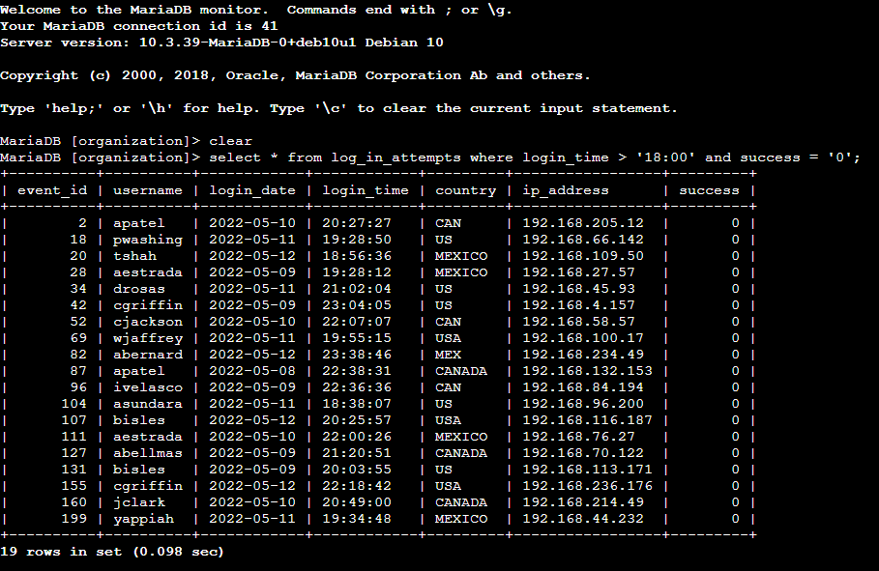
This views the table with the details I would need to investigate the security incident.

Retrieve login attempts on specific dates
In this next situation for the company, On 2022-05-09, a suspicious occurrence took place. I looked over each login attempt that took place on this day and the day before in order to look into this incident. Using select * from log_in_attempts where login_date = '2022-05-09' or login_date = '2022-05-08'; This shows the information that is needed to continue my investigation.
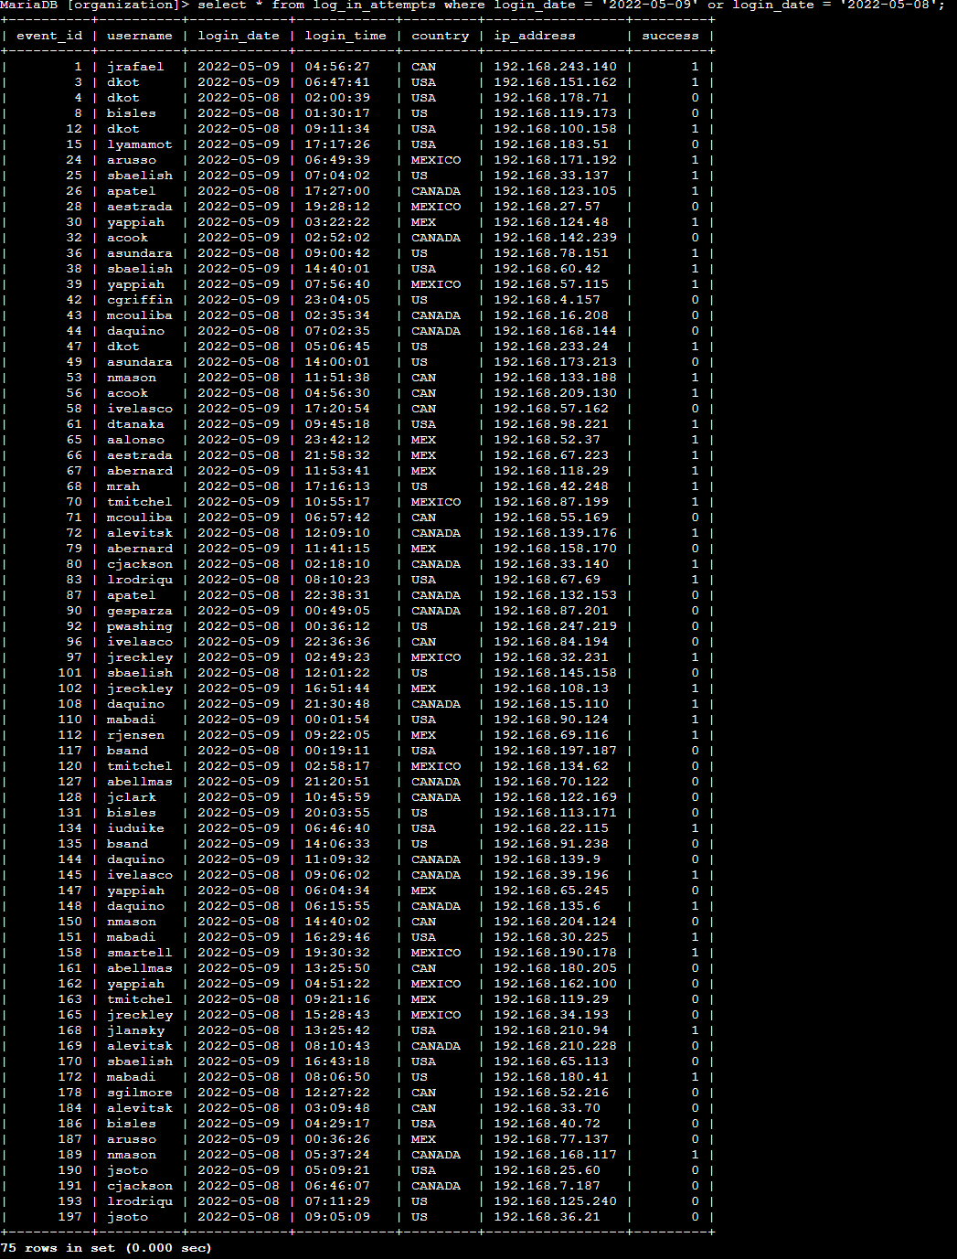

Retrieve login attempts outside of Mexico
Login attempts have shown some suspicious activity, but the team has found that this activity did not start in Mexico. I must now look into login attempts that took place outside of Mexico. Using select * from log_in_attempts where not country like 'mex%'; The result is as shown which is needed to continue the investigation.
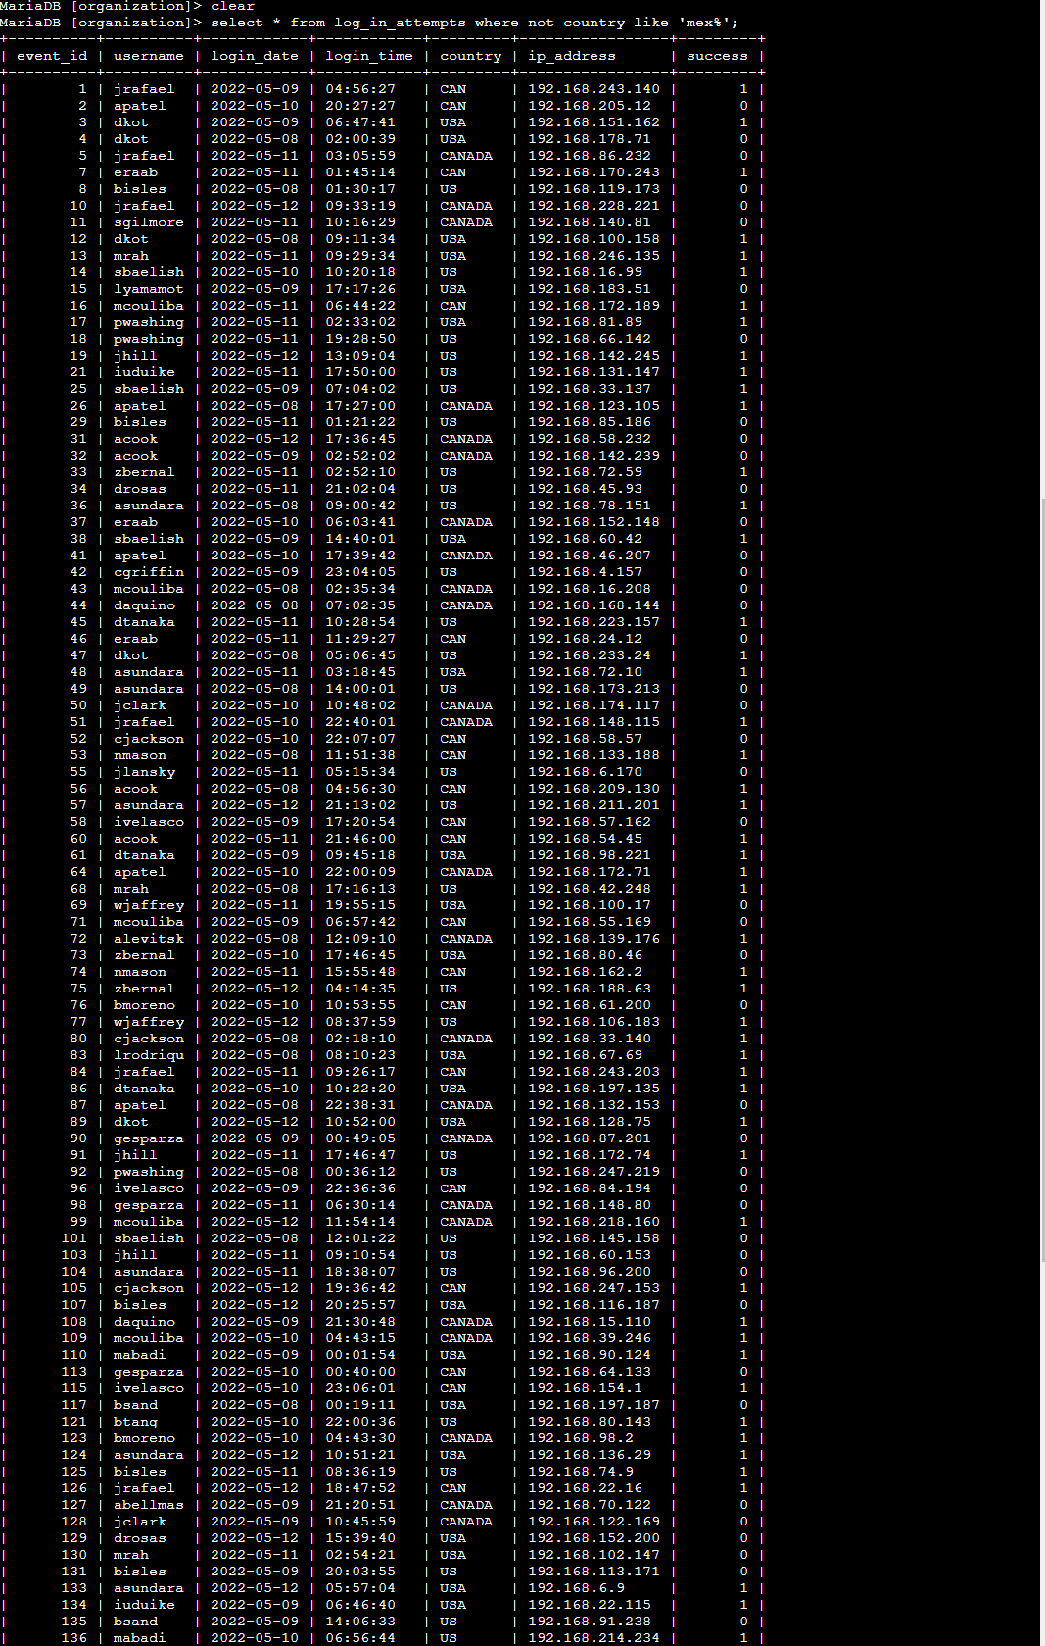
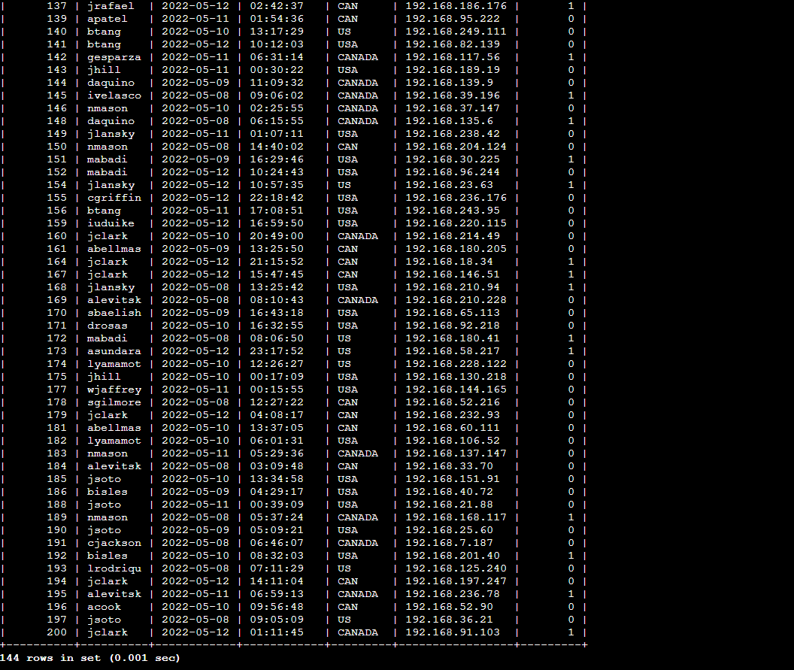

Retrieve employees in Marketing
In the Marketing department, my team wants to update the security on a few particular employee computers in the east department. I must run a query in the employees table in order to learn more about these employee machines in the specific department. I use the command select * from employees where department = 'marketing' and office like 'east%';. I can now update these employees' computers.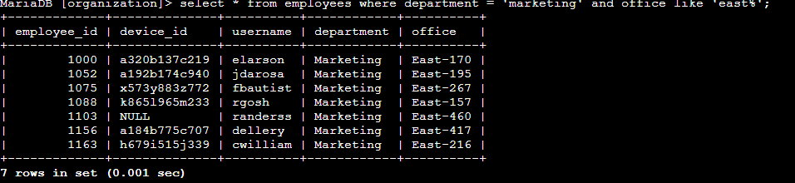

Retrieve employees in Finance or Sales
The machines used by staff members in the sales and finance departments now require our team to apply a different security update. Using select * from employees where department = 'finance' or department = 'sales';. Now our team can apply the update to these machines.
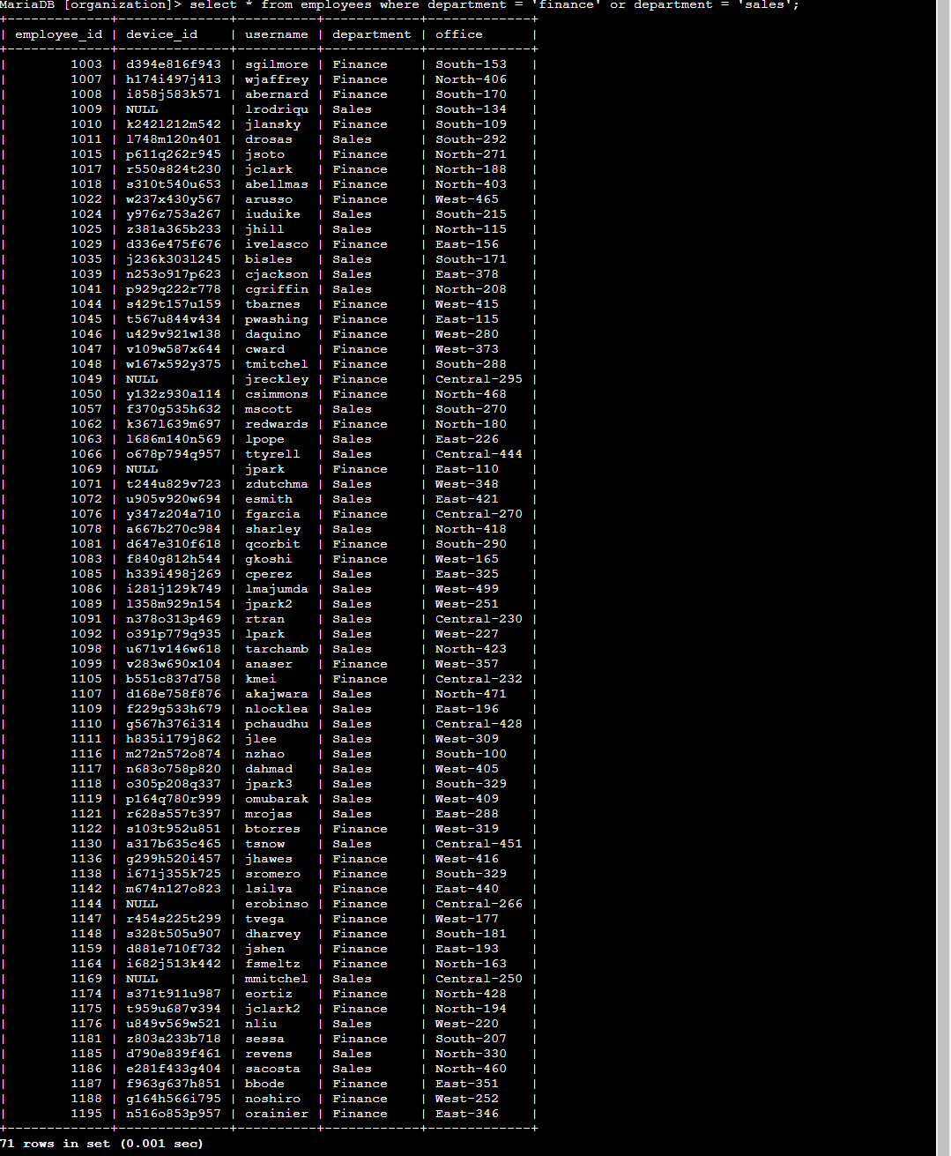

Retrieve all employees not in IT
One more change to the employee machines is required from our team. Employees in all other departments need this update, but those in the information technology department already have it. Using select * from employees where not department = 'information technology';. We now know what computers need this update not including information technology.
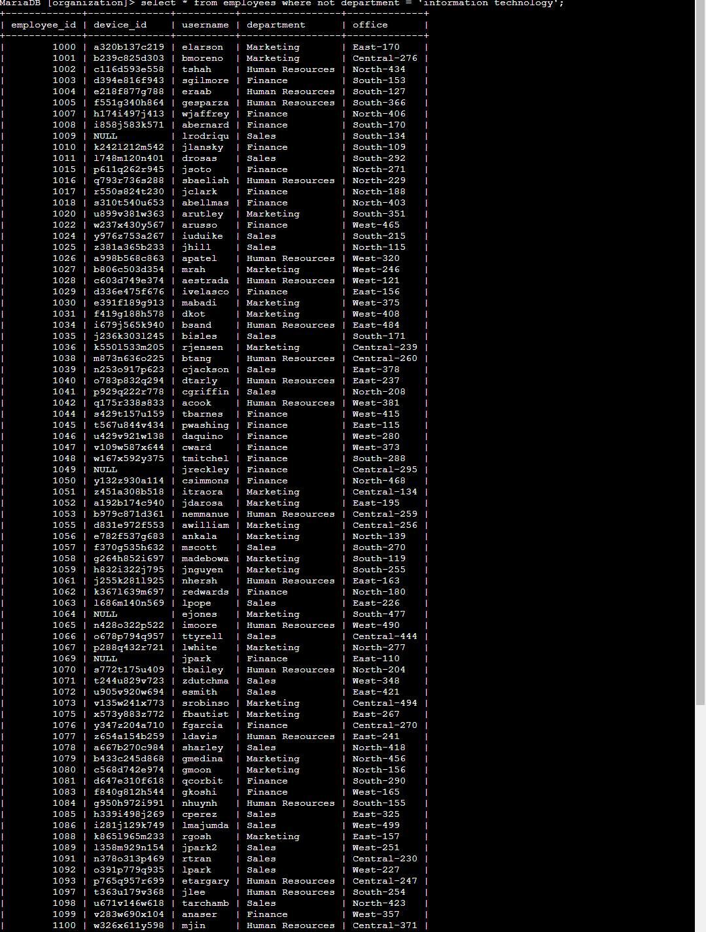
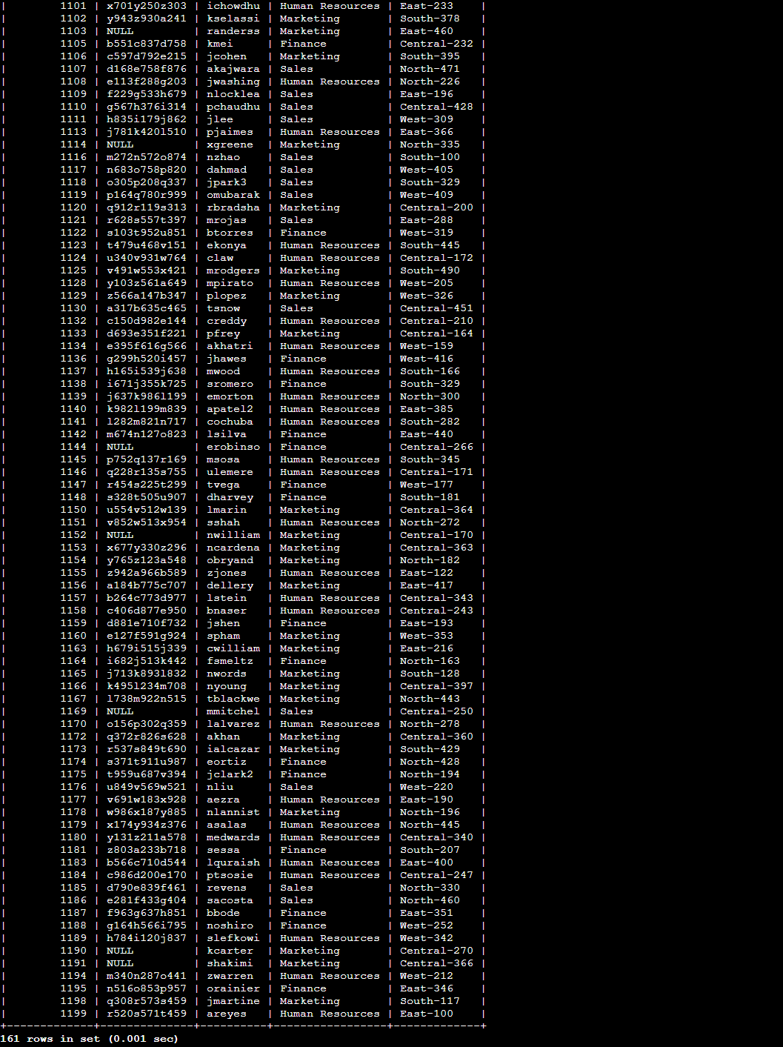

Summary
To obtain detailed information on login attempts and employee machines, I applied filters to SQL queries. Employees and log_in_attempts are the two tables I used. I filtered for the precise data required for each task using the AND, OR, and NOT operators. In order to search for patterns, I also used LIKE and the wildcard percentage sign (%).

